EUROPEAN KARATE-DO GOJU-KAI ASSOCIATION

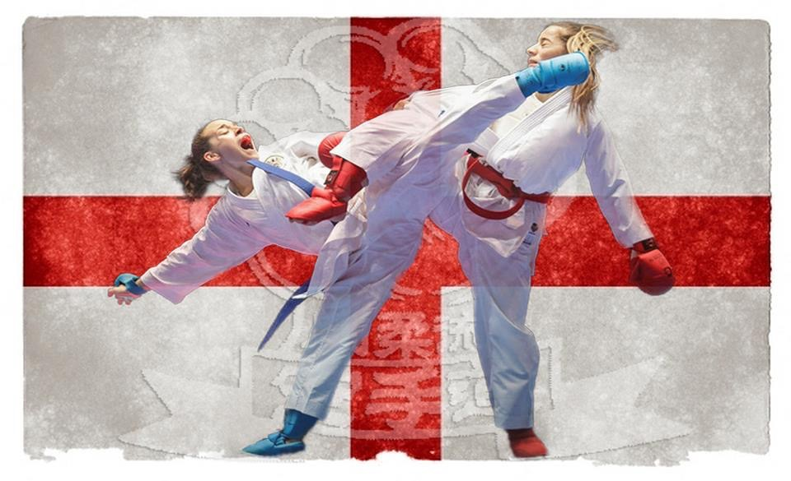

8th IKGA EUROPEAN CHAMPIONSHIPS

VENUE: Potters Resort, Coast Road, Hopton on Sea, NR31 9BX, England.
DATE: 14. 07. 2015.
TIME: 09.00 a.m.

Competition categories for kata
Cat KA1. 5-7 years boys
Cat KA2. 5-7 years girls
Cat KA3. 8-9 years boys.
Cat KA4. 8-9 years girls
Cat KA5. 10-11 years boys
Cat KA6. 10-11 years girls
Cat KA7. 12-13 years boys
Cat KA8. 12-13 years girls
Cat KA9. Cadet (14-15 years) boys
Cat KA10. Cadet (14-15 years) girls
Cat KA11. Junior (16-17 years) male
Cat KA12. Junior (16-17 years) female
Cat KA13. Senior 18 years + male
Cat KA14 Senior 18 years + female
Cat KA15 Veteran 45 years + male
Cat KA16 Senior 40 years + female
Cat KA17 Childrens team kata mixed 5 – 11 years
Cat KA18 Childrens team kata mixed 12 – 15 years
Cat KA19 Senior team kata 16 years + male
Cat KA20 Senior team kata 16 years + female
Cat KA21 Team Bunkai male
Cat KA22 Team Bunkai female

Categories will be amended/merged dependent on entries
Bunkai not required in team kata events

Competition categories for kumite

Cat KU23 5-7 years boys (category will be split on weight dependent on entries)
Cat KU24 5-7 years girls (category will be split on weight dependent on entries)
Cat KU25 8-9 years boys – 32 kg
Cat KU26 8-9 years boys + 32 kg.
Cat KU27 8-9 years girls – 30 kg
Cat KU28 8-9 years girls + 30 kg
Cat KU29 10-11 years boys – 34 kg
Cat KU30 10-11 years boys – 40 kg
Cat KU31 10-11 years boys + 40 kg
Cat KU32 10-11 years girls – 34 kg
Cat KU33 10-11 years girls – 40 kg
Cat KU34 10-11 years girls + 40 kg
Cat KU35 12-13 years boys – 45 kg
Cat KU36 12-13 years boys,– 52 kg
Cat KU37 12-13 years boys + 52 kg
Cat KU38 12-13 years girls – 43 kg
Cat KU39 12-13 years girls – 50 kg
Cat KU40 12-13 years girls + 50 kg
Cat KU41 Cadet (14-15 years) boys – 52 kg
Cat KU42 Cadet (14-15 years) boys – 57 kg
Cat KU43 Cadet (14-15 years) boys – 63 kg
Cat KU44 Cadet (14-15 years) boys-- 70 kg
Cat KU45 Cadet (14-15 years) boys +70kg
Cat KU46 Cadet (14-15 years) girls – 47 kg
Cat KU47 Cadet (14-15 years) girls – 54 kg
Cat KU49 Cadet (14-15 years) girls + 54 kg
Cat KU50 Junior (16-17 years) male – 55kg
Cat KU51 Junior (16-17 years) male – 61kg
Cat KU52 Junior (16-17 years) male – 68kg
Cat KU53 Junior (16-17 years) male – 76kg
Cat KU54 Junior (16-17 years) male + 76kg
Cat KU55 Junior (16-17 years) female – 48kg
Cat KU56 Junior (16-17 years) female – 55kg
Cat KU57 Junior (16-17 years) female – 59kg
Cat KU58 Junior (16-17 years) female + 59kg
Cat KU59 Senior (18 years +) male – 60kg
Cat KU60 Senior (18 years +) male – 67kg
Cat KU61 Senior (18 years +) male – 75kg
Cat KU62 Senior (18 years +) male – 84kg
Cat KU63 Senior (18 years +) male + 84kg
Cat KU64 Senior (18 years +) female – 50kg
Cat KU65 Senior (18 years +) female – 55kg
Cat KU66 Senior (18 years +) female – 61kg
Cat KU67 Senior (18 years +) female – 68kg
Cat KU68 Senior (18 years +) female + 68kg
Cat KU69 Veterans (45 years +) male open
Cat KU70 Senior (40 years +) female open
Cat KU71 Team (16 years +) male (3+1 competitors)
Cat KU72 Team (16 years +) female (3+1 competitors)

Categories will be amended/merged dependent on entries
Any categories with less than 4 competitor’s will be merged
Minimum of 3 Countries per category, if less the category will be merged
Repacharge for individual events 10 years and above

Please, consider the age of the competitors at the date of the championships!
Two teams per country per category will be allowed, Team Kata, Kumite and Bunkai.

REGISTRATION AND WEIGH IN:
13th of July, (time to be confirmed), locker area outside arena.

Entry fee: Individual categories £25.00, two categories £40.00.
Team kumite, team kata and kata bunkai £30.00.
Rules: WKF system, kata bunkai IKGA rules.
Kumite: 1,5 minutes for age 8-13,
Cadets, Juniors & Senior female 2 minutes,
Senior male 3 minutes,
Kata Individual and Team: Children aged 5 - 13 - minimum 2 kata required.
Cadets, Juniors, Seniors and Veterans – each round a new Goju-kai kata should be performed each round.
Kata Suparunpei is not allowed for 5-13 years age categories.
Bunkai: Will be two rounds, different bunkai each round, top eight will go through to next round.
Protection: Gum shields, WKF type mitts red and blue, for women chest protector,
WKF type shin pads and foot protection red and blue are compulsory. For cadets and children additionally WKF type face mask and body protector are optional. .
Prizes: 1-3 places: medals and certificates, the winner of each category will receive a
Trophy.

Goju-Kai Best all round competitor Male and Female award
As fist awarded in the European Championships Bern Switzerland 2007 Best Male and Best Female competitor, the competitor must compete in Kata, Kumite and Bunkai, the trophy will be awarded to the competitor with the highest placing in each of the events.
Protest: The protest has to be submitted in writing to the referee council of the tournament and £50.00 protest fee has to be deposited. If the protest is accepted by the referee council, the fee will be refunded.
Referees: Referees are going to be delegated by the Organising Committee. Chief referee to be confirmed, WKF - EKF referee. Foreign qualified referees (WKF, EKF or the highest national qualification is required!) are welcome! Please, send your application of your referees in writing to the Organising Committee!
Responsibility: The organisation committee will not bear any responsibility for any kinds
of damages or losses.
ATTENTION: All competitors must have their own red and blue belts.
Entries and fee’s required by 1st April 2015, (required by this date because need to confirm categories prior to purchase of trophies and medals).
Entry Fee payment to: Barclays Bank PLC, Leicester LE87 2BB, United Kingdom.
Account name: IKGA 2015 Seminar Ltd
Account number: 93288404 Sort Code: 20 : 70 : 93
IBAN: GB68BARC20709393288404 Swift Code: BARCGB22
Reference payment with Country name / tournament fees.
PLEASE REMEMBER TO BRING YOUR COUNTRY FLAG AND NATIONAL ANTHEM

Address for applications:
Mark Adams
24 Fairway
Grays
Essex
RM16 2AD

E-mail: mark.adams30@btopenworld.com

Phone: **(44) 1375 384153

Mobile phone: **(44) 7711 817253

We look forward to seeing you at the tournament.

Best regards,
Mark Adams
Yamaguchi Goju-Kai

Tournament Organiser

